PUBLIC NOTICE

PRIMARY ELECTION DATES

NOTICE is given that pursuant to Colorado Revised Statutes, the Clerk and Recorder’s Election Department is convening the following boards in coordination of the June 28, 2022, Primary Election:

June 3, 2022 Public Logic and Accuracy Testing (will begin at 9 a.m.)
July 11, 2022 Risk-Limiting Audit (will begin at 1 p.m.)
July 15, 2022 Canvass Board (will begin at 9 a.m.)

The Public Logic and Accuracy Test, Risk-Limiting Audit, and Canvass Board will be held at the Adams County Election Department, 4430 S. Adams County Pkwy., Ste. E3102, Brighton, CO 80601. Such meetings may be continued from day to day and time to time as necessary until completion. This notice may be revised if dates change. Interested parties may receive information regarding these activities by calling 720.523.6500.

Dated this 26th of May, 2022.

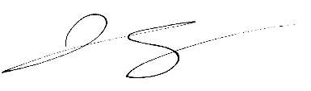

Josh Zygielbaum
Adams County Clerk and Recorder

