PUBLIC NOTICE

GENERAL ELECTION DATES

NOTICE is given that pursuant to Colorado Revised Statutes, the Clerk and Recorder’s Election Department is convening the following boards in coordination of the November 3, 2020, General Election:

October 8, 2020 Public Logic and Accuracy Testing (will begin at 9 a.m.)
November 17, 2020 Risk-Limiting Audit (will begin at 9 a.m.)
November 20, 2020 Canvass Board (will begin at 9 a.m.)

The Public Logic and Accuracy Test will be held at the Adams County Election Department, 4430 S. Adams County Parkway, Ste. E3102, Brighton, CO 80601. The Risk-Limiting Audit and Canvass Board are scheduled to be conducted remotely due to the pandemic. Such meetings may be continued from day to day and time to time as necessary until completion. This notice may be revised if dates change. Interested parties may receive information regarding these activities by calling 720.523.6500.

Dated this 1st of October, 2020.

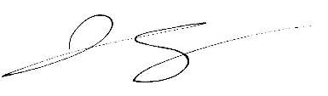

Josh Zygielbaum
Adams County Clerk and Recorder

